My whatsapp number +6590230772

I have gave you my project file with a game inside and my database

What I need are indicated here and also, to link up with my game so when the customer wins, they are able to enjoy the discount which will be reflected in their ordering systems

Key to take note:

1. Ensure ordering system can be ordered and ordered again but it will be displayed and generated in order list with total sum and display the food they have ordered
2. Allows discount generated from the game the customer win.

Frontend ordering system.

1. This display the menu of the restaurant

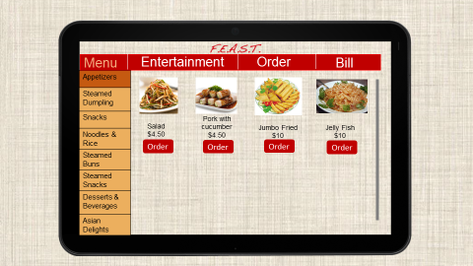

1. When the customer wants to it, they will click on the order button and it will pop up this message. They can indicate the quantity they want(I prefer it to be in the dropdown list) and if there’s any special request in the remarks. Once they are done, they will click on confirm button which will later redirect them to number 1 again.

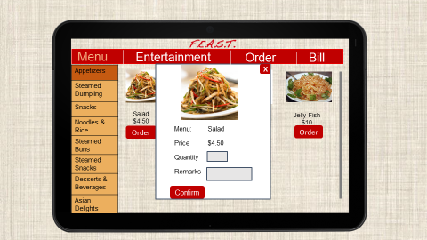

1. This one is where the customer can view all the orders they have made earlier and have a final check if its correct. If its correct, they will send it the orders. If its wrong or if they want to make some amendment to it, they can click on the edit button which will direct them to point 4. Actually I missed out a total price in this page. I would like to see a total price after all the orders. Also, there should have a delete button to delete the orders they don’t want.

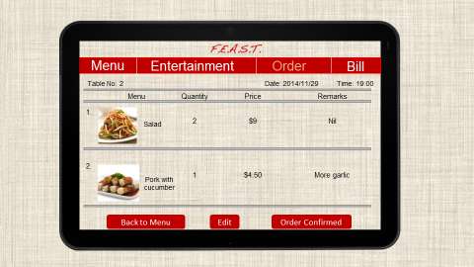

1. This one allow the customer to change the quantity. While the quantity is changed, the price will be auto generated and displayed as well. So once they click done, it will be back to point 3.

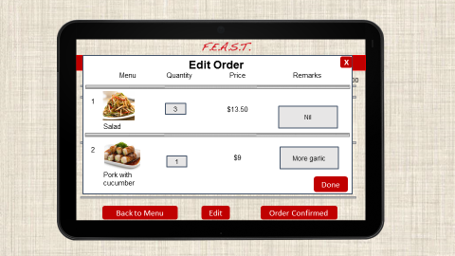

1. Once the ordering is done, there will be a timer to that countdown from 20mins. This is like a assurance to the customer that their food will be served with the time frame. This shall then be displayed at the top right hand corner after the customer has ordered.

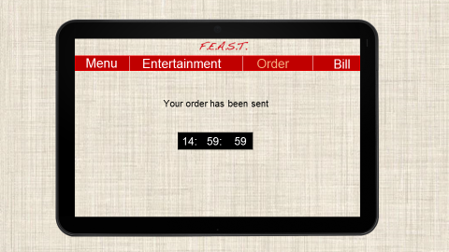

1. I didn’t make a slides for this, but I would like to have a page(it can be in order or what) to show the food they have ordered. So it will display all the food that was sent in point 4. If cases like the customers would like to order more, this page will autogenerated and display the total price.

Backend

1. This is how the backend should looks like. Firstly, the different colour in timing is to warn the staff that the time is running out. It should be displaying the orders that was sent by customer. So in the ordering there buttons with the word “Processing” (I missed out this),“Done” and “Sent” . Basically “processing” means the food is being processed, “Done” means the food is done waiting to be served, and “Sent” means the food has been sent to the customer. It can be in button or a dropdown list but most importantly the logic is like this. When order has been complete, the staff will click on the order complete button and it will pop up a message in point. The colour changes like this, 0-5mins(red), 6-10mins(orange), 11-15(white)

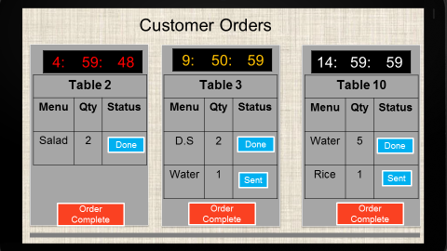

1. There will be a pop up message to prompt the staff.

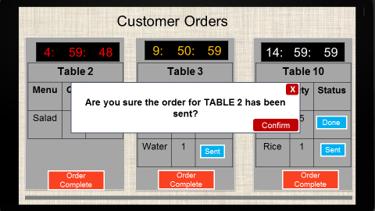

1. Once the staff confirm it, it will disappeared and the remaining orders will be pushed to the left. 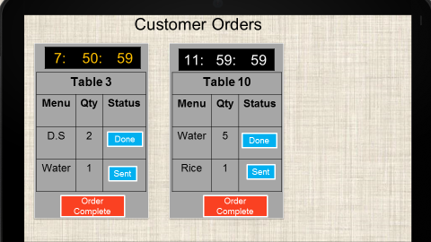
2. So after that, the front end will display a message like this and the timer will be gone. 